**110550126 曾家祐**

**Homework 1: Face Detection**

**Part I. Implementation :**

* **Part 1:**

1. **dataset.py -> loadImages()**

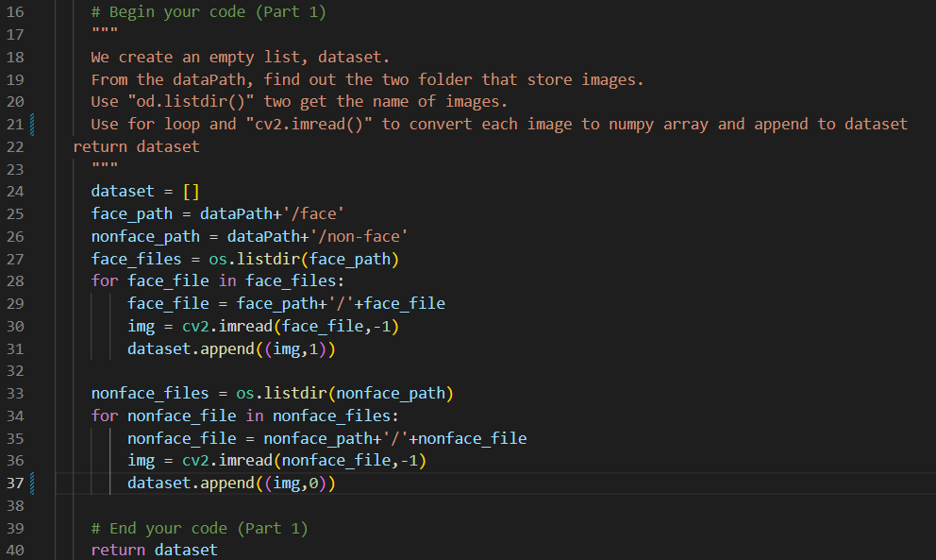

1. **adaboost.py-> selectbest()**

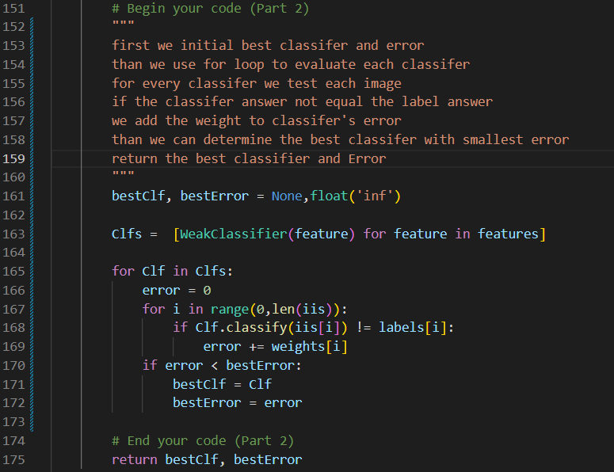

* **PartII. Results & Analysis**

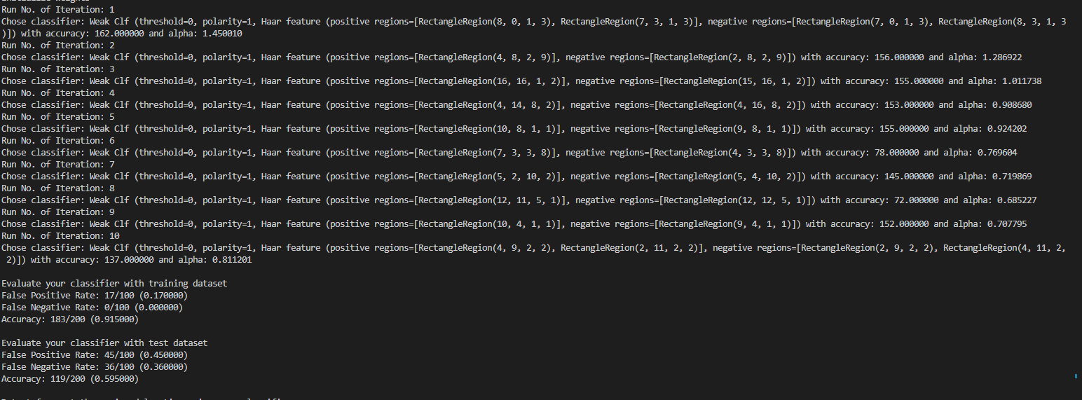

**Training model with T = 10**

**The table below is the result of our training model with t from 1~10,20,30,40,50. We can see that when t increase train data accuracy increasing , but t increase and have peak value at t = 10**

|  |  |  |
| --- | --- | --- |
| **200張** | **Train data accuracy** | **Test data accuracy** |
| **Method 1 t=1** | **81.0%** | **48.0%** |
| **Method 1 t=2** | **81.0%** | **48.0%** |
| **Method 1 t=3** | **88.0%** | **53.0%** |
| **Method 1 t=4** | **86.0%** | **47.5%** |
| **Method 1 t=5** | **88.5%** | **54.0%** |
| **Method 1 t=6** | **89.0%** | **51.0%** |
| **Method 1 t=7** | **90.0%** | **54.5%** |
| **Method 1 t=8** | **91.0%** | **55.0%** |
| **Method 1 t=9** | **90.0%** | **57.5%** |
| **Method 1 t=10** | **91.5%** | **59.5%** |
| **Method 1 t=20** | **97.0%** | **57.5%** |
| **Method 1 t=30** | **100.0%** | **54.0%** |
| **Method 1 t=40** | **99.5%** | **54.5%** |
| **Method 1 t=50** | **100.0%** | **54.0%** |

**Other t value**

**However when testing using image, the result with t = 2 is more higher than t = 10. This may because of the lack of training data and testing data or overfitting in the model.**

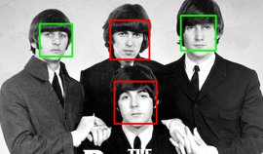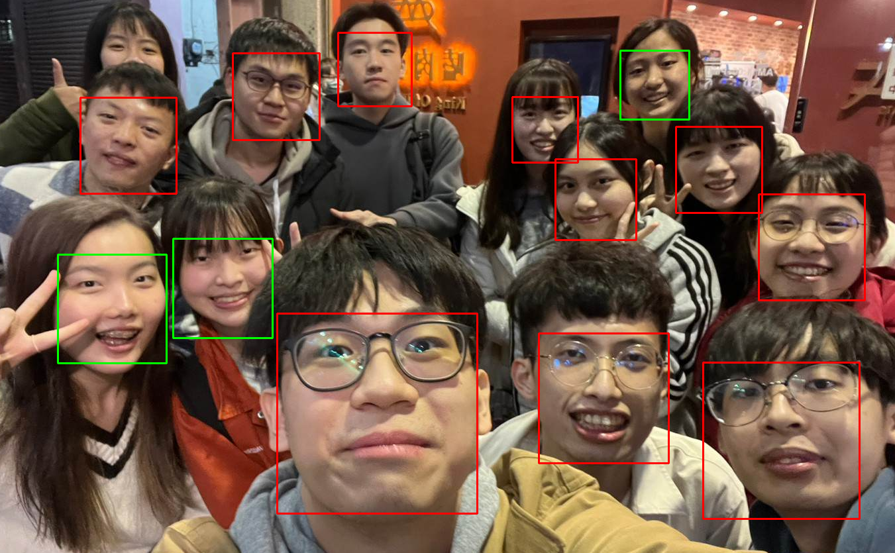

**⬆**Face detection “the-beatles.jpg” Face detection “my_pic.jpg” **⬆**

⬇Face detection “p110912sh-0083.jpg”

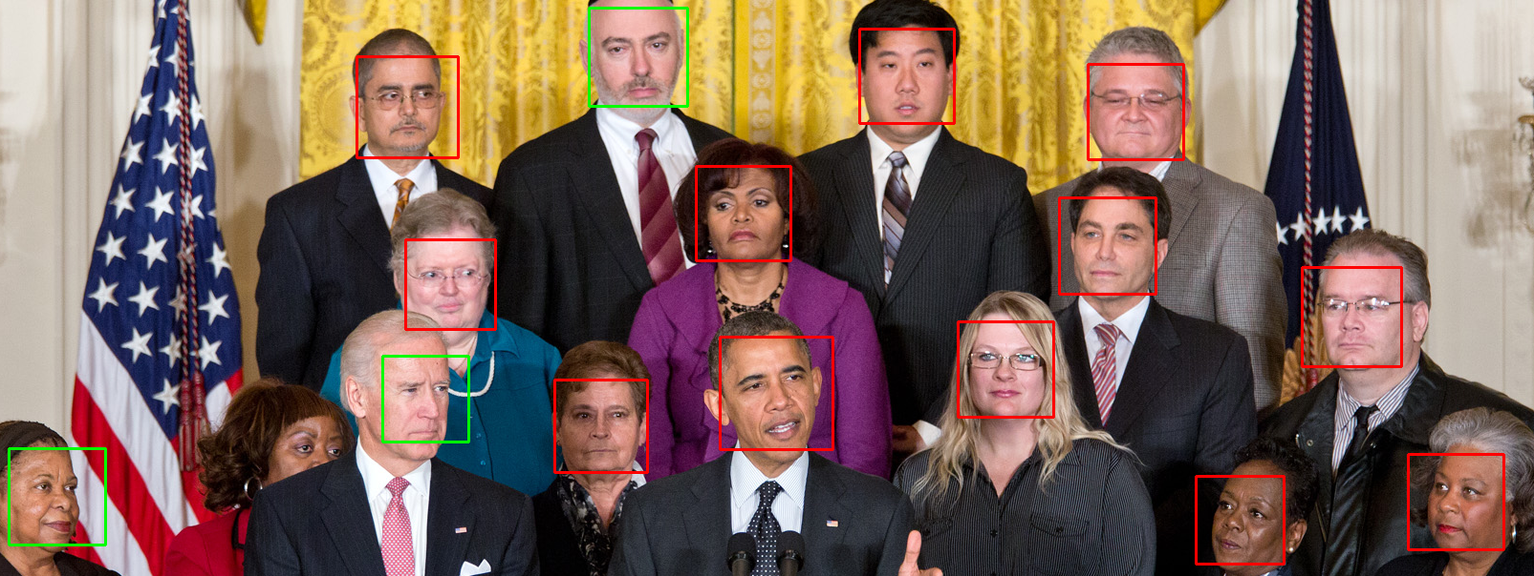

**With value t = 10**

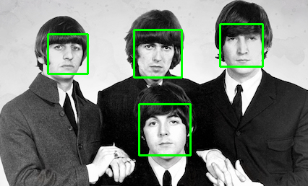 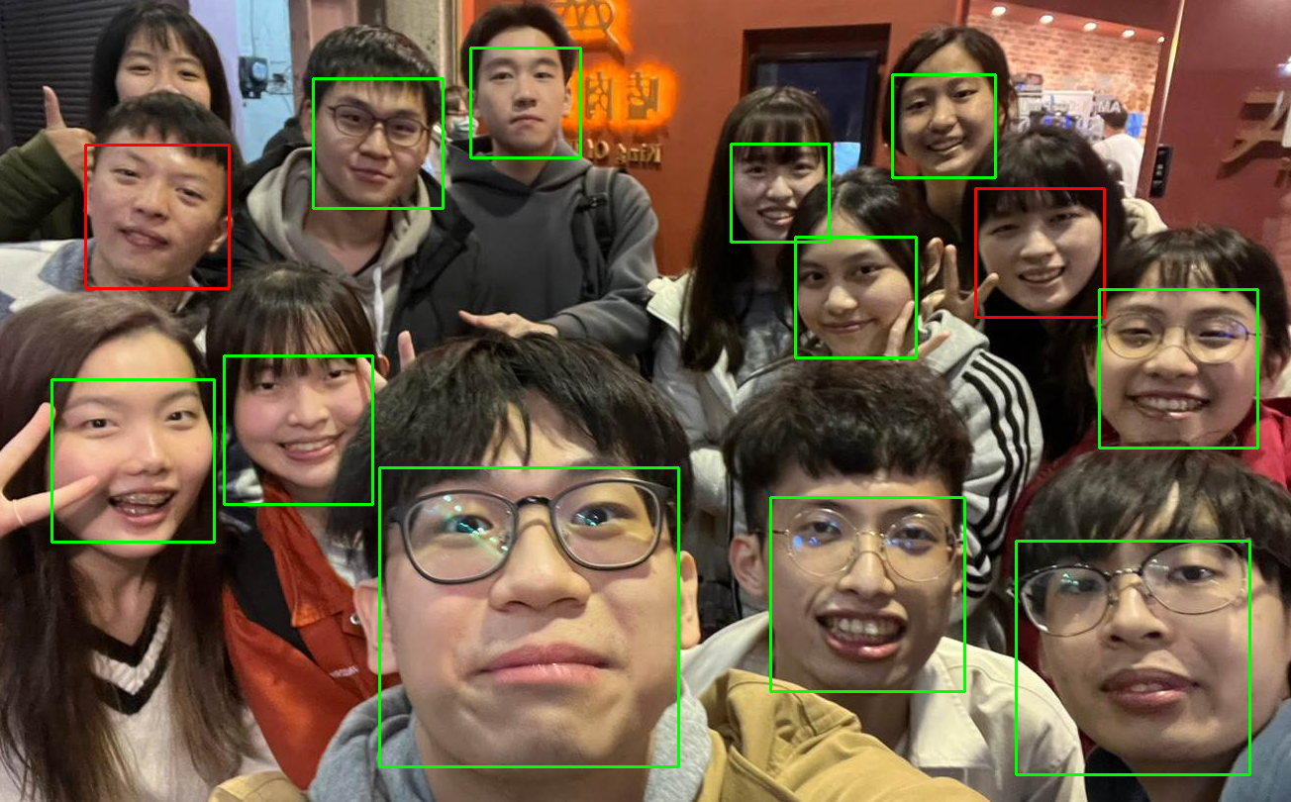

**⬆**Face detection “the-beatles.jpg” Face detection “my_pic.jpg” **⬆**

⬇Face detection “p110912sh-0083.jpg”

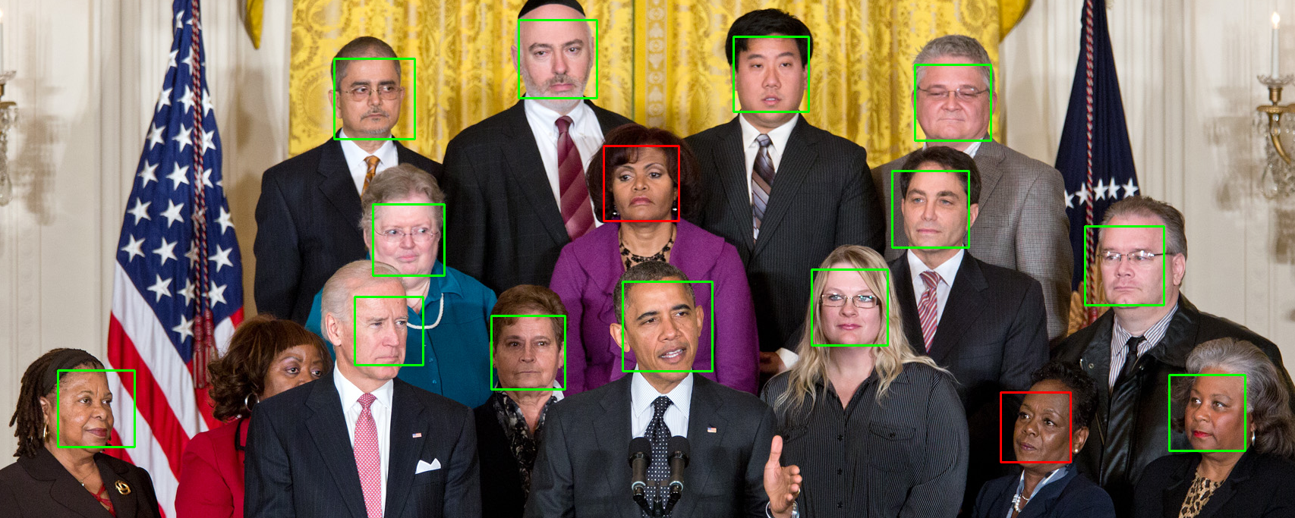

**With value t = 2**

* **Part III. Answer the questions**

1. Please describe a problem you encountered and how you solved it.

2. What are the limitations of the Viola-Jones’ algorithm?

3. Based on Viola-Jones’ algorithm, how to improve the accuracy except changing the training dataset and parameter T?

4. Other than Viola-Jones’ algorithm, please propose another possible face detection method (no matter how good or bad, please come up with an idea). Please discuss the pros and cons of the idea you proposed, compared to the Adaboost algorithm